LAB 3 – QUERIES

TABLES:-

SUPPLIER TABLE:-

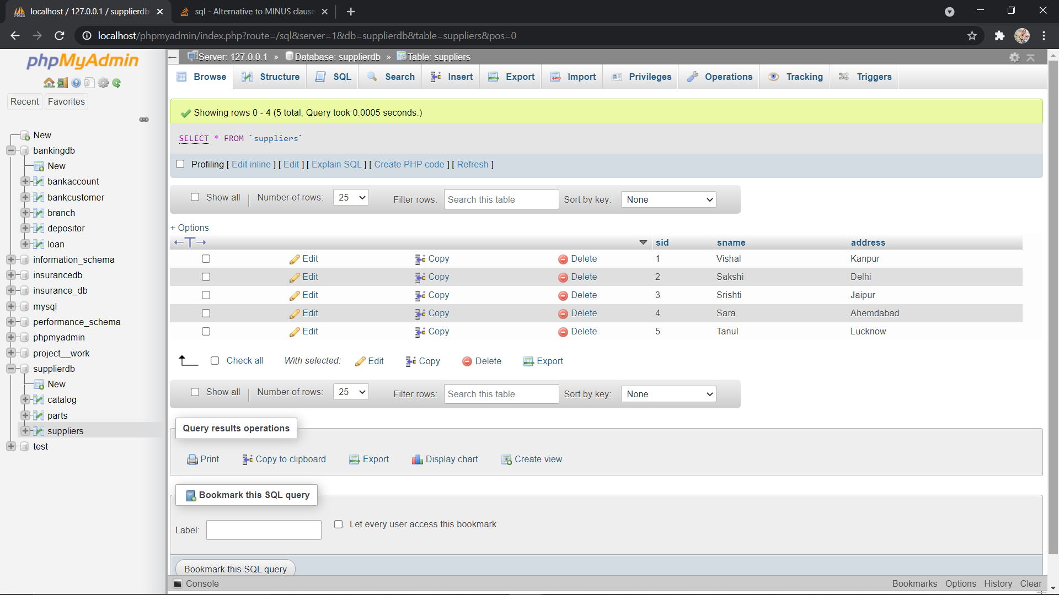

PARTS TABLE:-

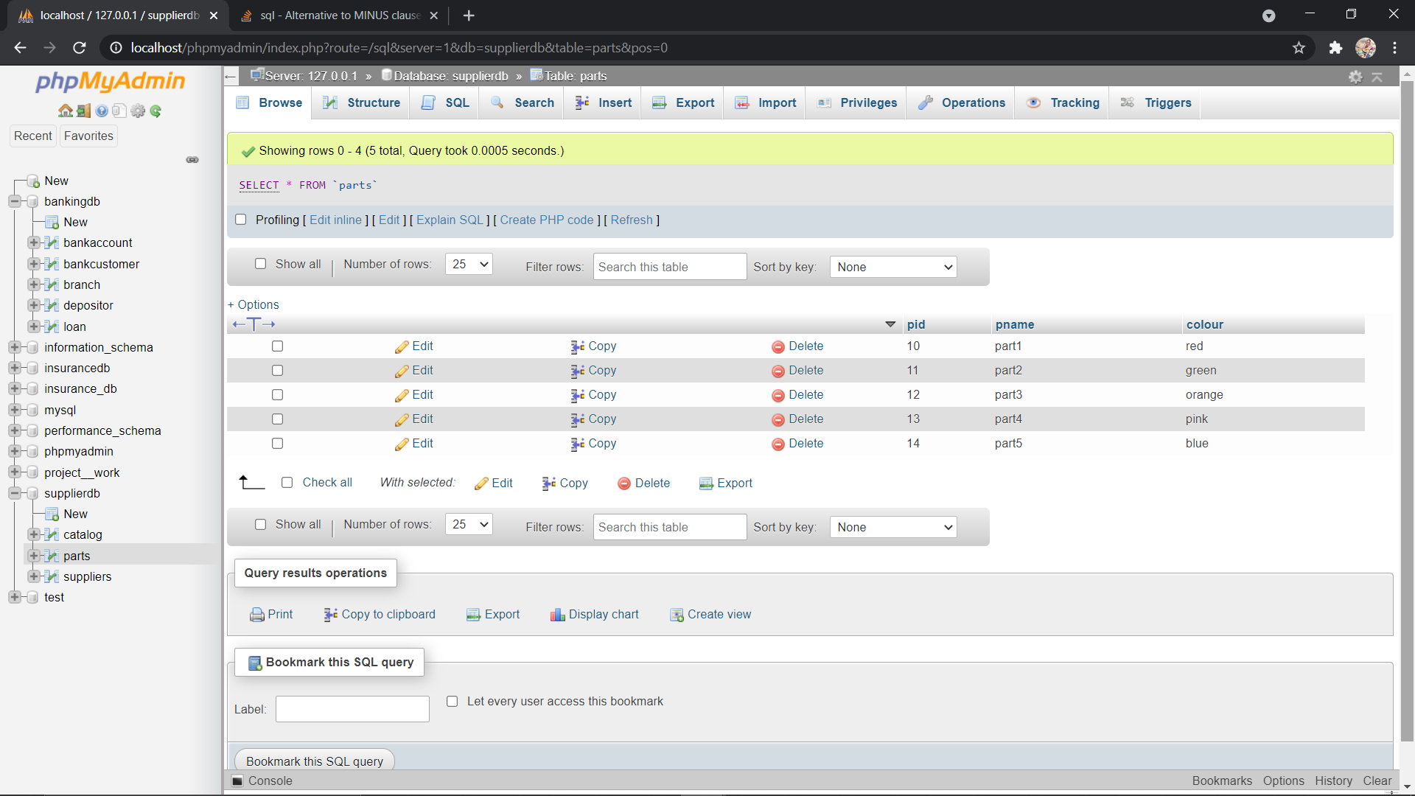

CATALOG TABLE:-

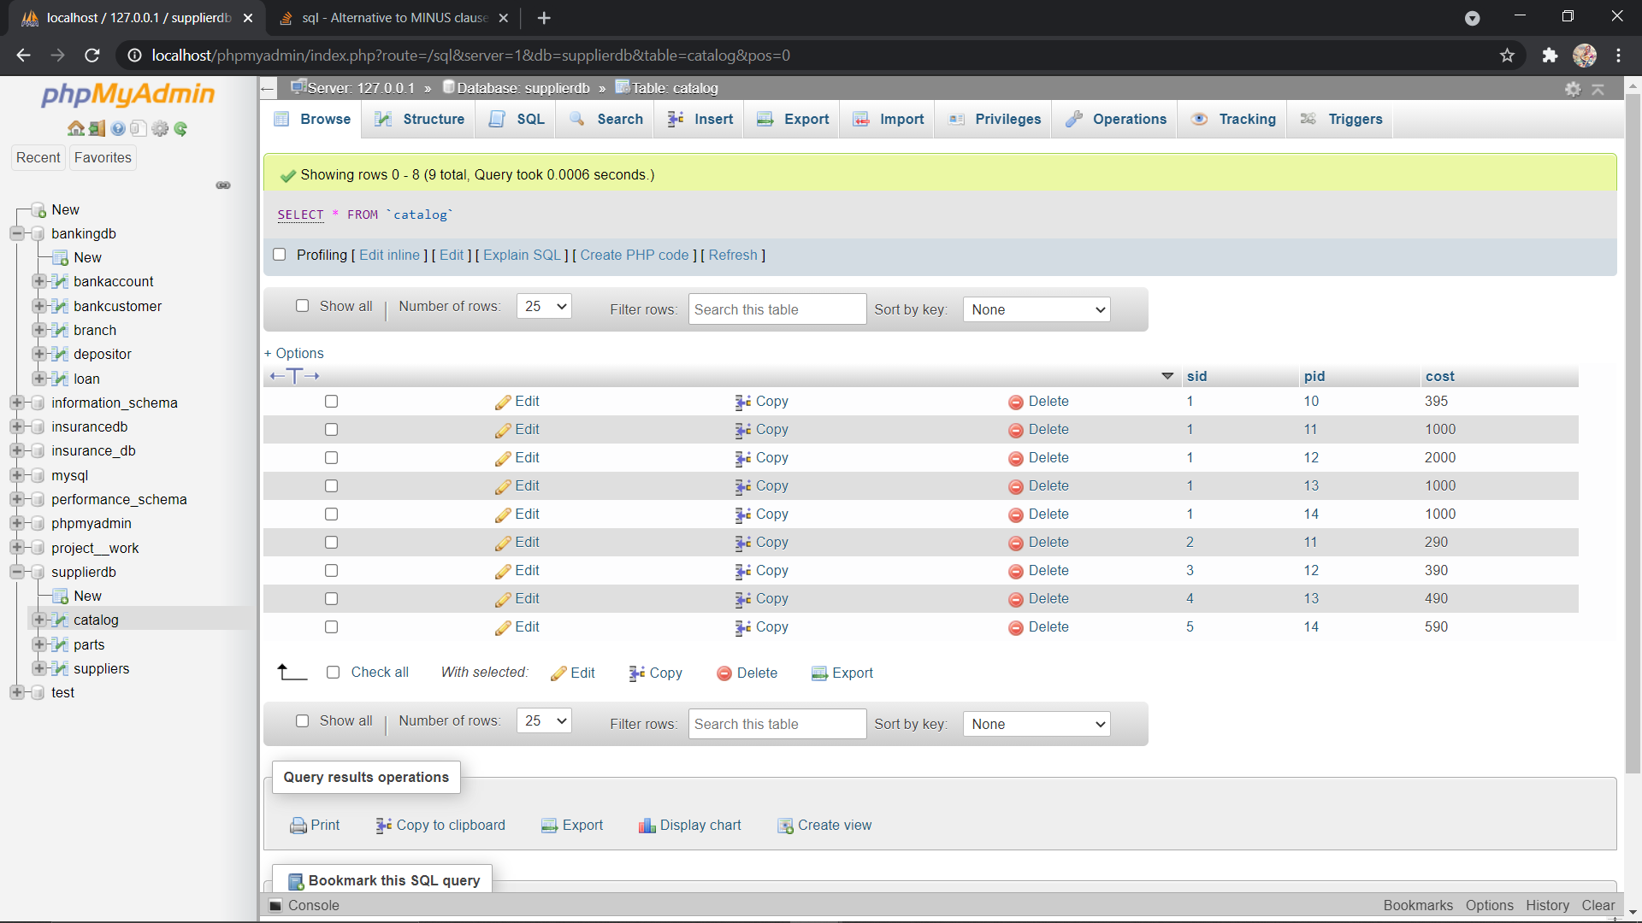

Find names of parts for which there is some supplier:

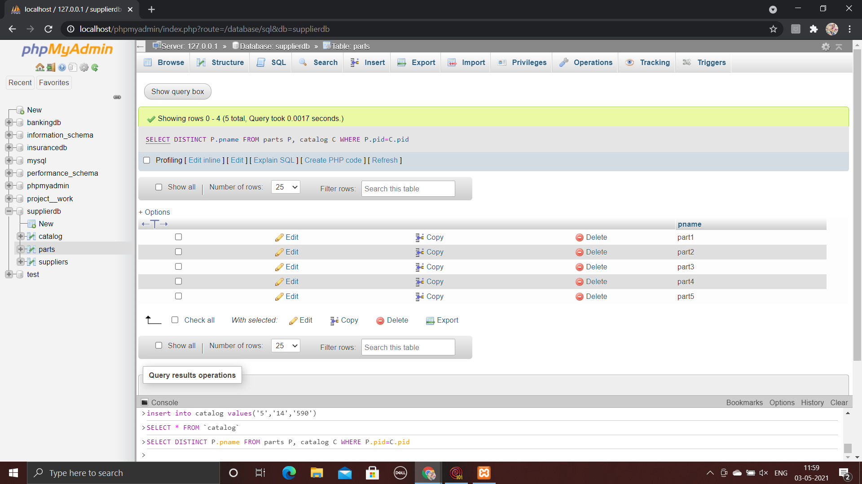

Find the names of the suppliers who supply every part:

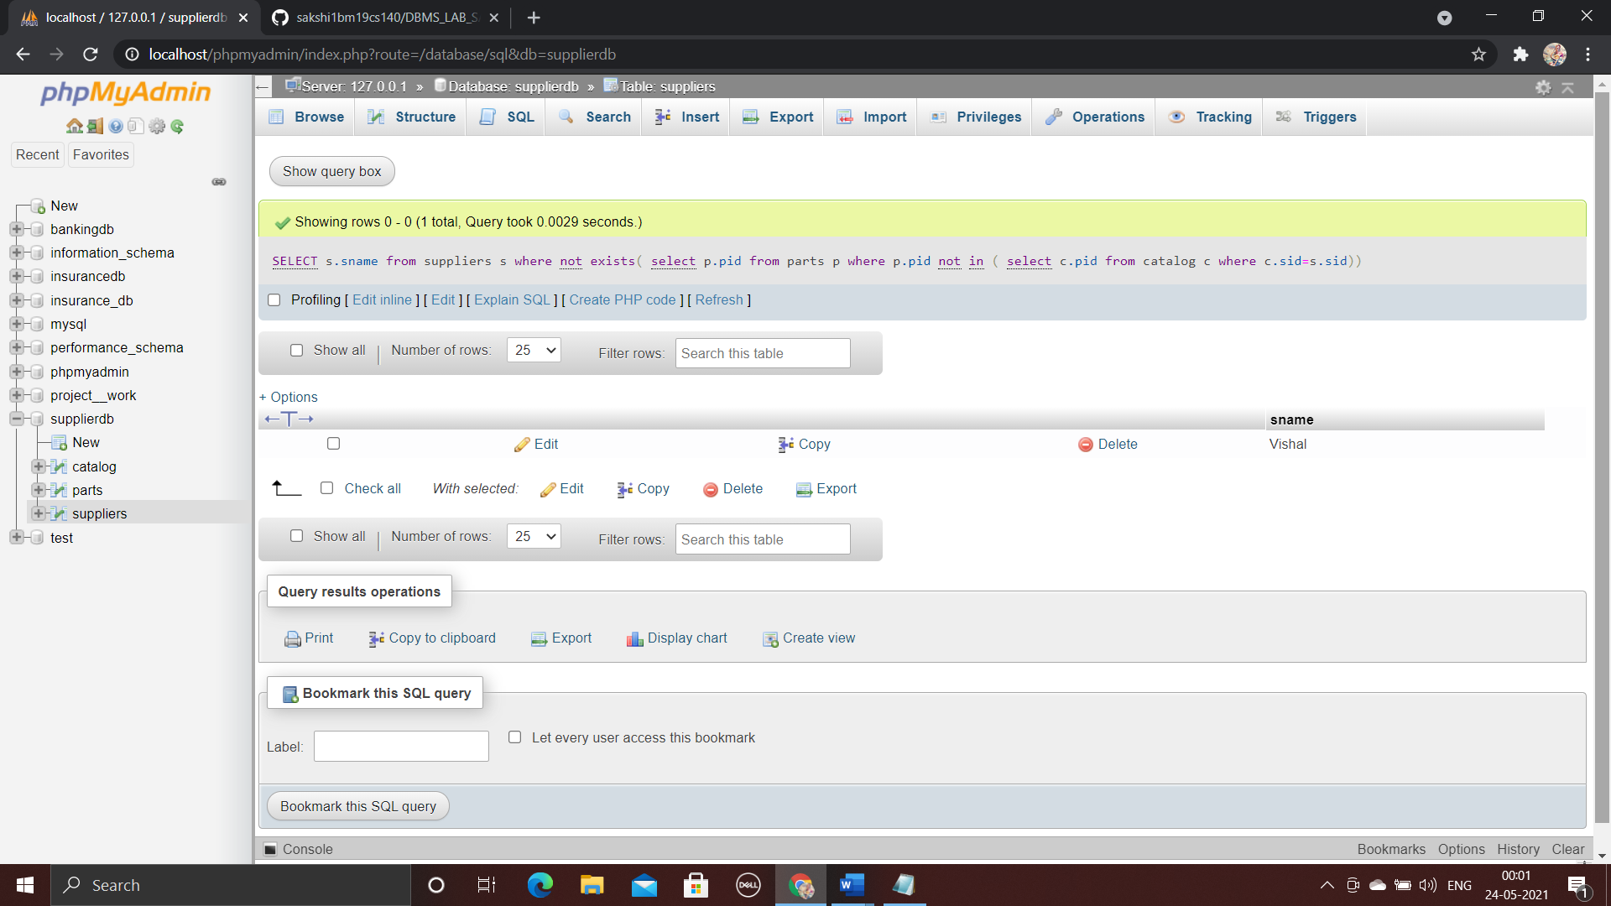

Find the names of suppliers who supply every red part.

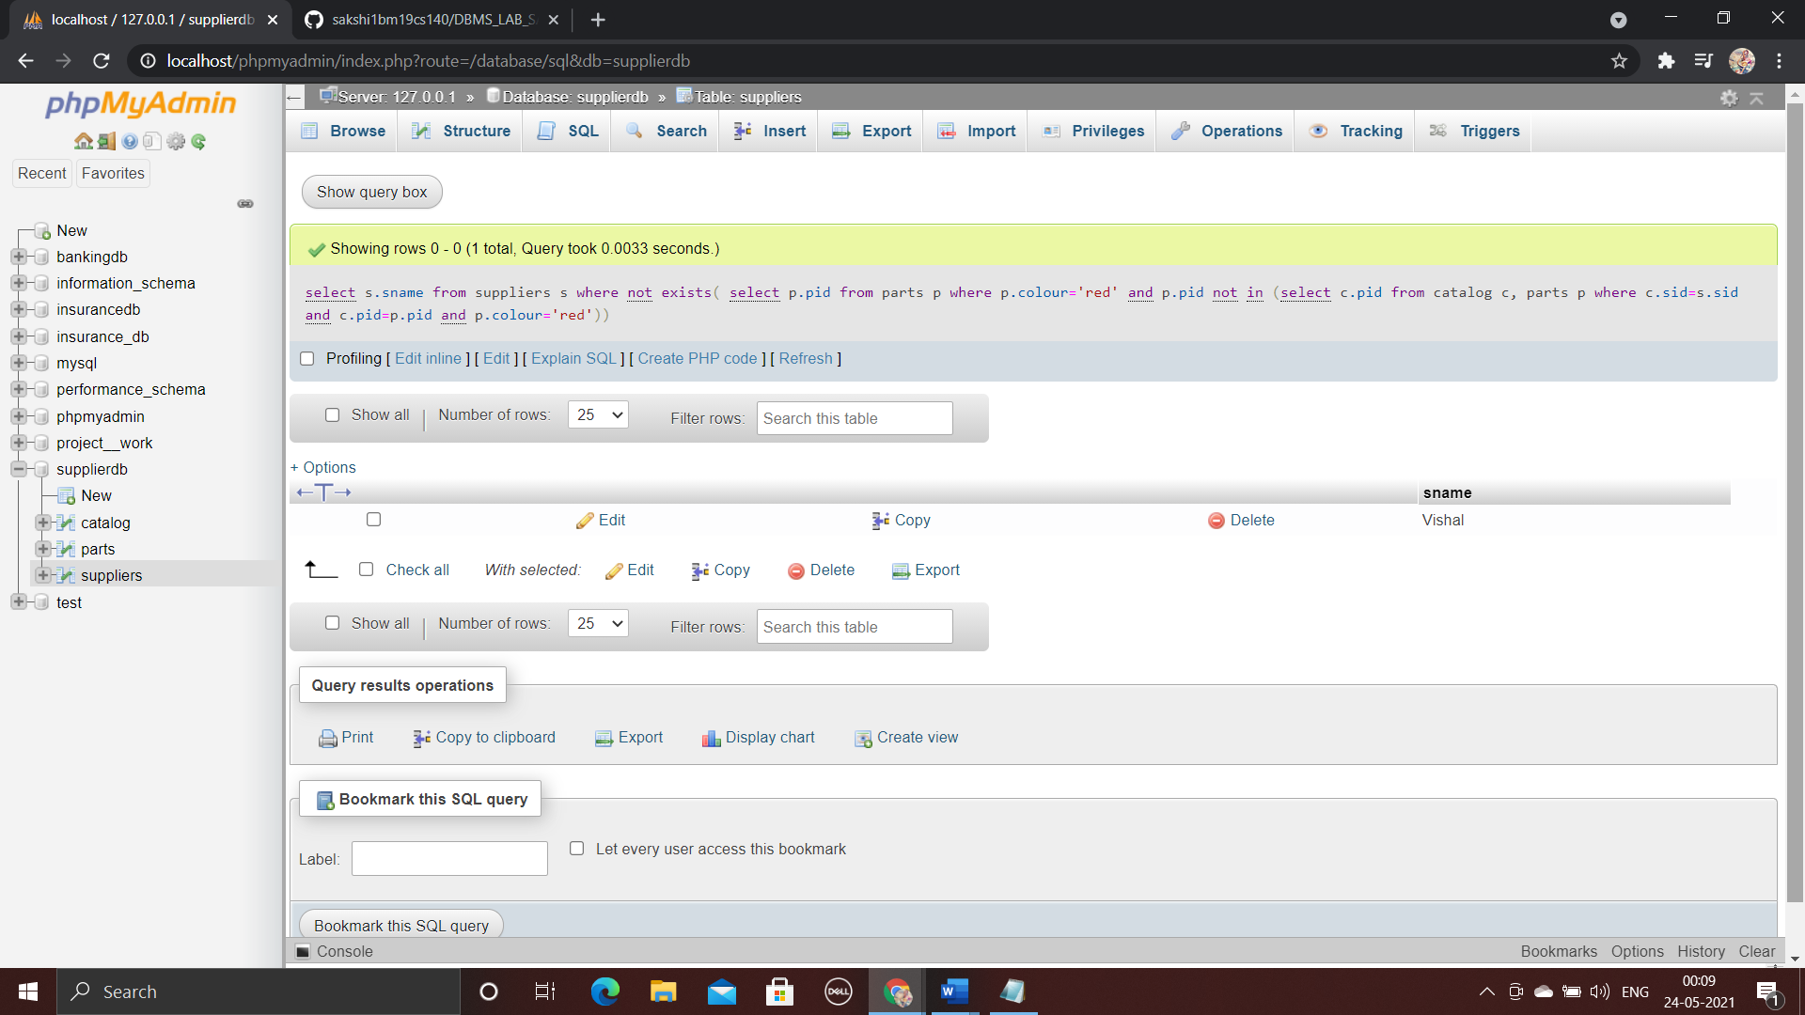

Find the ids of suppliers who charge more for some part than the average cost of that part (averaged over all the suppliers who supply that part).

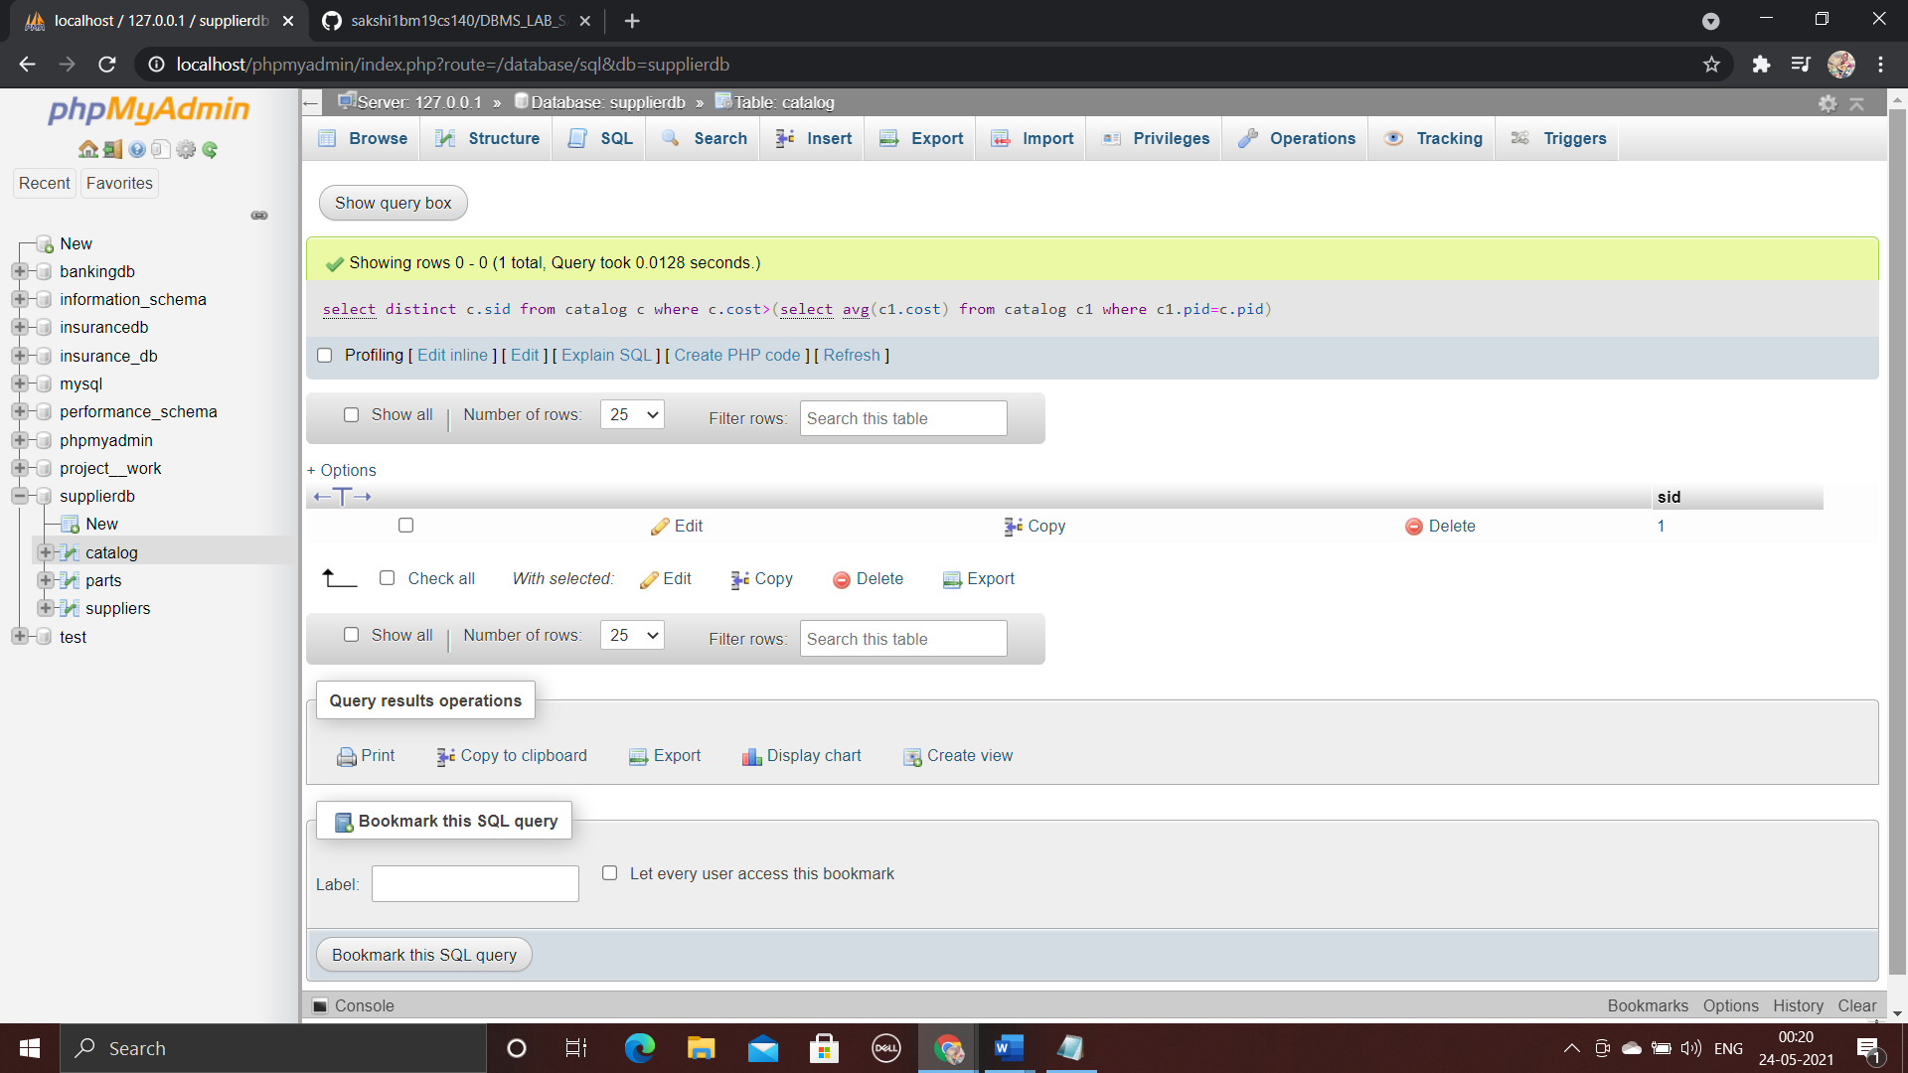

For each part, find the name of the supplier who charges the most for that part.

